User Studies

Add Description to user feedback

Upload before:

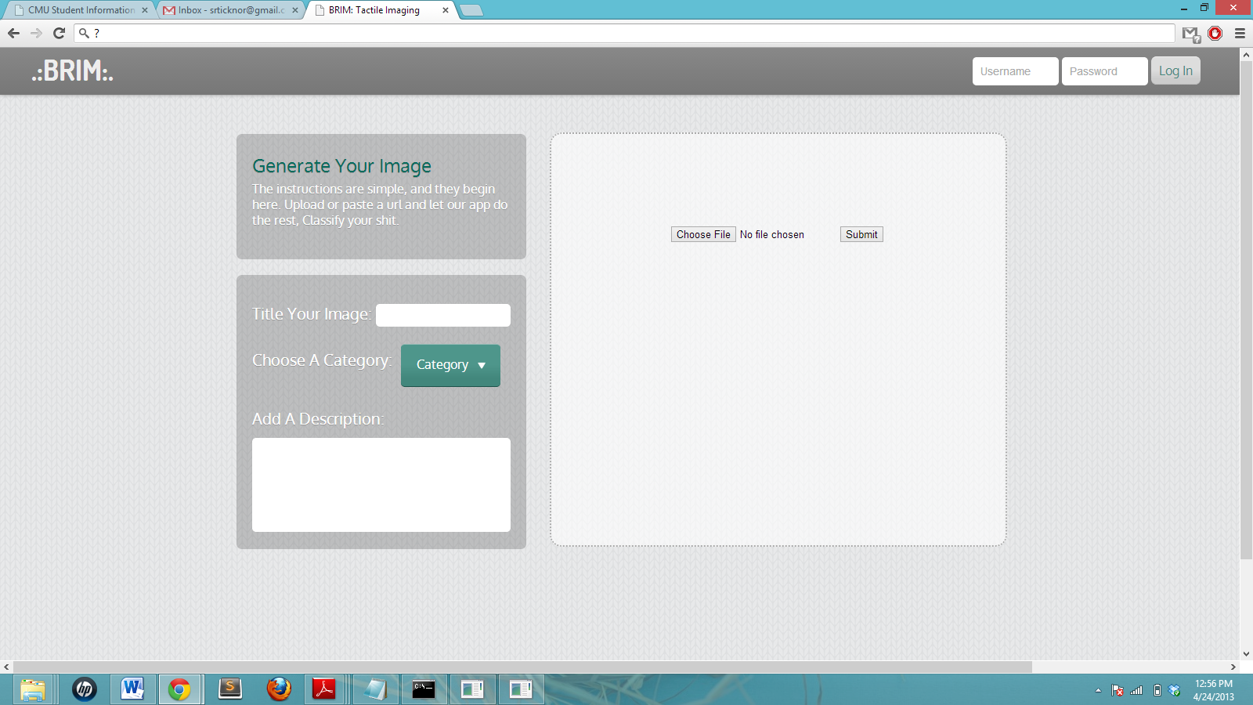

Upload after: Added an X button in case you want to cancel the upload

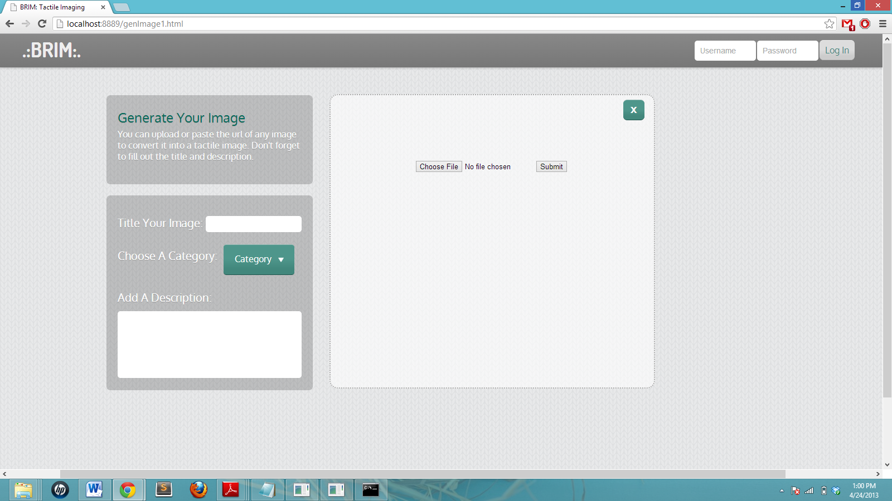

The URL Feature is now working

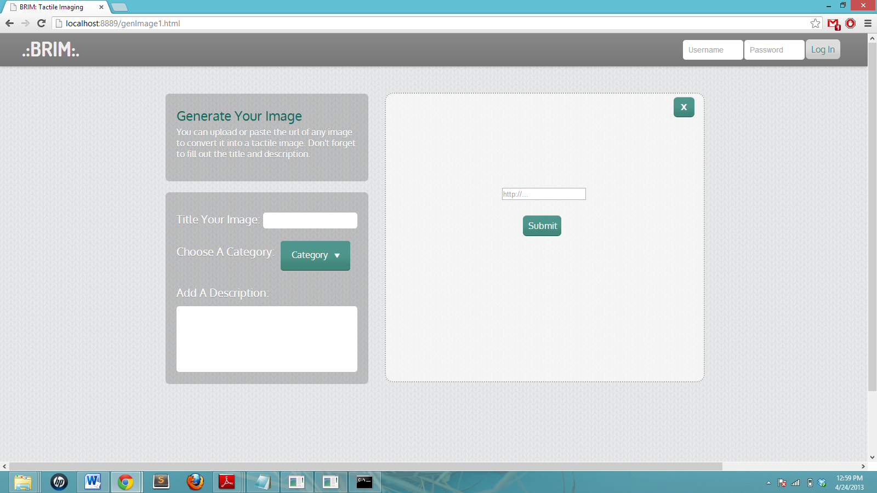

Added the convert button ONLY once image is uploaded, so people don’t try to ‘convert’ nothing

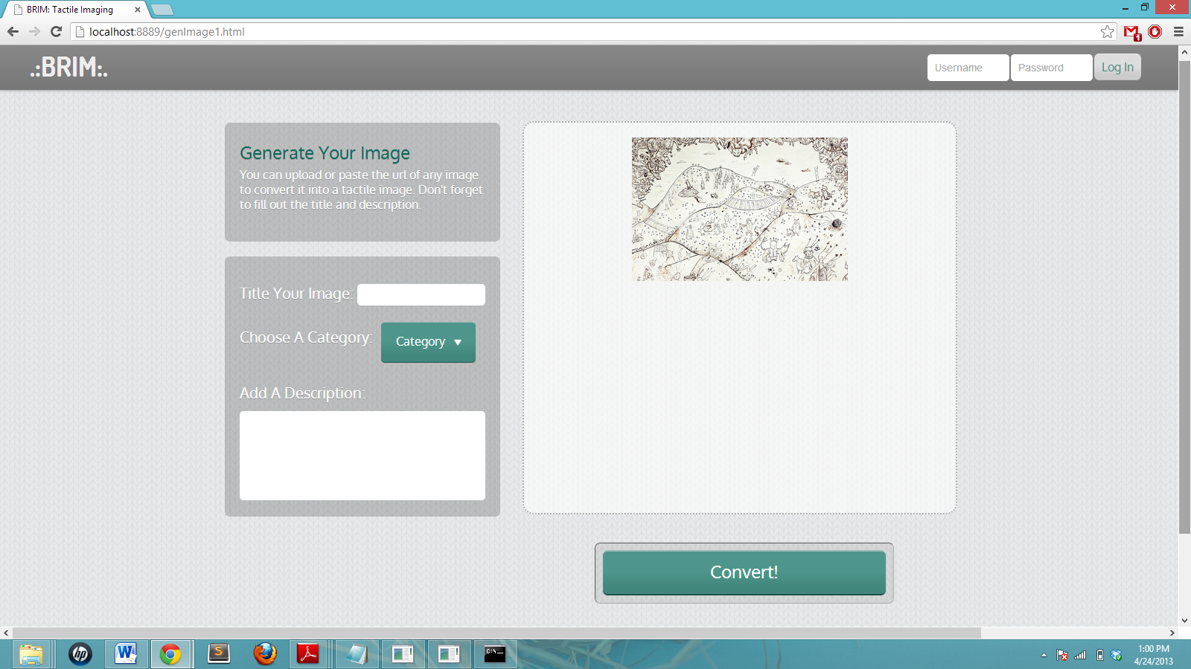

Save and New Image Buttons appear after file has been converted and only presents Save if logged in.

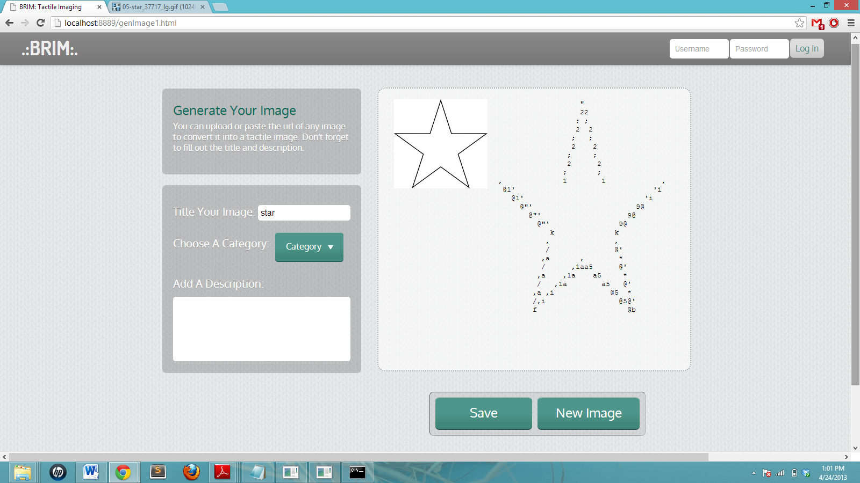

Other notes and things to fix:

1. Register button next to log in
2. Home Screen about us, smaller and lower because less important
3. Want to see the converted braille, not the text file, for a better preview
4. Option to ‘save’ image to user library vs download text file to print
5. Different filter options on braille image (coded but not included in app yet)
6. Make the Browse functionality
7. Adapt to changes in screen size (mobile, tablet)
8. Couple bugs:
   1. Image persists if not converted or new image pressed
   2. Buttons in menu, hard to click, only text is clickable, fix this
   3. Log in/ log out buttons glitchy (not working in generate screen)